[](https://www.genmymodel.com/)

# Talent Route1

Author: giovannacamilo44474

Date: 2022-09-03

# Talent Route1 (Model)

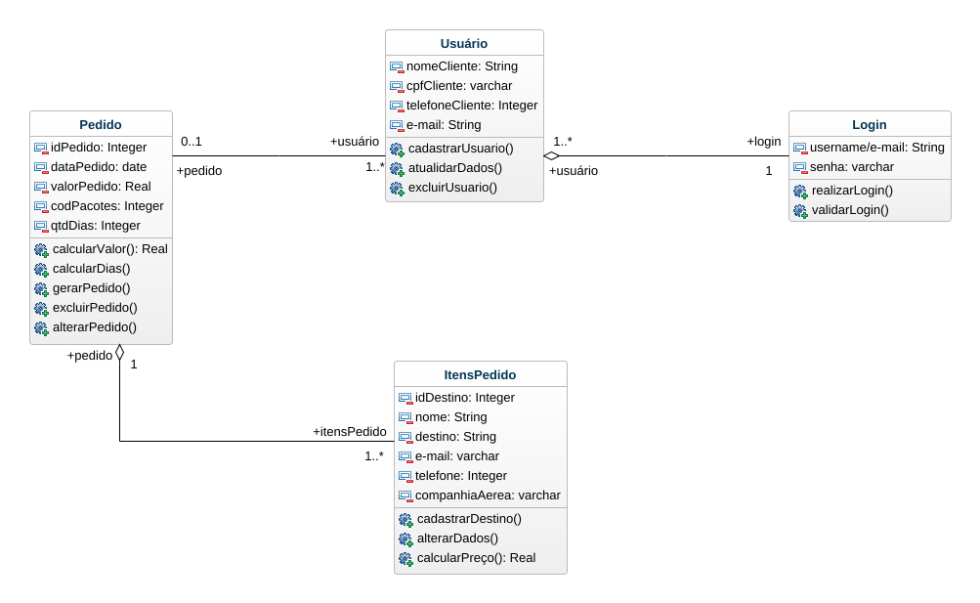

Talent-route

## 1. ItensPedido (Class)

In Talent Route1

| Attributes |
| --- |
| idDestino : Integer [1] |
| nome : String [1] |
| destino : String [1] |
| e-mail : varchar [1] |
| telefone : Integer [1] |
| companhiaAerea : varchar [1] |

| Operations |
| --- |
| cadastrarDestino |
| alterarDados |
| calcularPreço : Real |

| Associations |
| --- |
| Pedido_Pacotes - pedido : Pedido [1] - see definition |

## 2. Login (Class)

In Talent Route1

| Attributes |
| --- |
| username/e-mail : String [1] |
| senha : varchar [1] |

| Operations |
| --- |
| realizarLogin |
| validarLogin |

| Associations |
| --- |
| Usuário_Login - usuário : Usuário [1..*] - see definition |

## 3. Pedido (Class)

In Talent Route1

| Attributes |
| --- |
| idPedido : Integer [1] |
| dataPedido : date [1] |
| valorPedido : Real [1] |
| codPacotes : Integer [1] |
| qtdDias : Integer [1] |

| Operations |
| --- |
| calcularValor : Real |
| calcularDias |
| gerarPedido |
| excluirPedido |
| alterarPedido |

| Associations |
| --- |
| Pedido_Pacotes - itensPedido : ItensPedido [1..*] - see definition |
| Pedido_Usuário - usuário : Usuário [1..*] - see definition |

## 4. Usuário (Class)

In Talent Route1

| Attributes |
| --- |
| nomeCliente : String [1] |
| cpfCliente : varchar [1] |
| telefoneCliente : Integer [1] |
| e-mail : String [1] |

| Operations |
| --- |
| cadastrarUsuario |
| atualidarDados |
| excluirUsuario |

| Associations |
| --- |
| Usuário_Login - login : Login [1] - see definition |
| Pedido_Usuário - pedido : Pedido [0..1] - see definition |

## 5. date (DataType)

In Talent Route1

## 6. varchar (Interface)

In Talent Route1